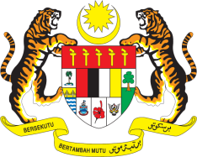

STATEMENT BY MALAYSIA
REVIEW OF FRANCE
43RD SESSION OF THE UPR WORKING GROUP
1 – 12 MAY 2023

Malaysia thanks France for its national report.

- In the spirit of constructive engagement, Malaysia recommends the following:

3.1 Intensify efforts to ensure effective response to matters related to hate crime, Islamophobia, racism, racial discrimination, xenophobia and other related intolerance directed at ethnic and religious minorities;

3.2 Fulfil its commitment to promote freedom of religion or belief by swiftly amending laws that prohibits the covering of face by Muslim women in public spaces for religious reasons and take steps to ensure that these women are not restricted from fully enjoying public life and accessing public services as a result of this prohibition; and

3.3 Take steps to investigate complaints on the excessive use of force by law enforcement officials during protests and demonstrations and ensure perpetrators are brought to justice.

- We wish France a successful review.

Thank you.

1 MAY 2023
GENEVA

