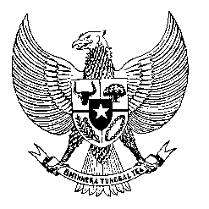

Permanent Mission
of the Republic of Indonesia to the UN, WTO,
and Other International Organizations
in Geneva

STATEMENT BY THE DELEGATION OF THE REPUBLIC OF INDONESIA
AT THE 43rd SESSION OF THE UPR WORKING GROUP
CONSIDERATION OF THE UPR REPORT OF LIECHTENSTEIN
9 May 2023

Thank you, Mr. Vice-President

Indonesia thanks Liechtenstein for its report.

We welcome Liechtenstein’s signing of the Convention on the Rights of Persons with Disabilities and ratification of some other important treaties relevant to human rights since the last cycle.

In a constructive spirit, we recommend that Liechtenstein:

- Immediately ratify the Convention on the Rights of Persons with Disabilities.

- Fulfill the rights of freedom to manifest one's religion or beliefs in teaching, practice, worship and observance, including to have places of worship.

- Effectively enforce the Criminal Code criminalizing hate speech and discrimination, including on the basis of religion.

- Protect the rights of migrants, refugees and asylum seekers, including from unlawful treatment by law enforcement officials.

- Urge Liechtenstein’s national human rights institution to apply for accreditation with the Global Alliance of National Human Rights Institutions (GANHRI).
Finally, we wish Liechtenstein delegation a successful review.

Thank you.

