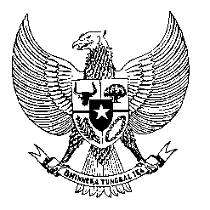

Permanent Mission
of the Republic of Indonesia to the UN, WTO,
and Other International Organizations
in Geneva

STATEMENT BY THE DELEGATION OF THE REPUBLIC OF INDONESIA
AT THE 43rd SESSION OF THE UPR WORKING GROUP
CONSIDERATION OF THE UPR REPORT OF THE UNITED ARAB EMIRATES, 8 May 2023
Thank you, Mr. Vice-President,

Indonesia thanks the UAE for its report.

In a constructive spirit of engagement, Indonesia recommends that the UAE:

- Reconsider ratifying the International Convention on the Protection of the Rights of All Migrant Workers and Members of Their Families.

- Ensure that all rights of migrant workers are safeguarded in terms of minimum wage, overtime payment, humane environment of work, and the right to create or join a union.

- Strongly consider to establish and implement alternative sentencing outside capital punishment and/or other appropriate remedies mechanism, in serious cases involving migrant workers.

- Adopt measures to guarantee the right to nationality and prevent cases of statelessness, including by easing the process for the newly-born children of unwed mothers to get birth certification.
We commend the newly-established national human rights institution in the UAE, its efforts to amend laws on freedom of expression and the commitment to proposing a new law on freedom of press.

We wish the UAE delegation a very successful review.

Thank you.

Word Count: 169 words
Max. Speaking Time: 1 minute.

