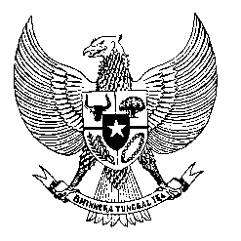

Permanent Mission
of the Republic of Indonesia to the UN, WTO,
and Other International Organizations
in Geneva

Statement
by the Delegation of the Republic of Indonesia
at the 43th Session of the UPR Working Group
Consideration of the UPR Report of Montenegro
8 May 2023

Thank you, Mr. President,

Indonesia thanks Montenegro for its report.

We commend Montenegro's efforts to strengthen the fight against domestic violence and violence against women and children, including by establishing the Operational Team, 2018 Protocol, and a single database system.

To further improve human rights in Montenegro, Indonesia offers the following recommendations:

- Develop strategies and programs to combat discrimination and exclusion of minority groups in education and employment access;

- Ensure provisions of the draft law amending the Criminal Code are in full compliance with Montenegro's international law obligations, including - but not limited to - the Convention against Torture and Other Cruel, Inhuman or Degrading Treatment or Punishment.

- Strengthen the independence of its Ombudsman in a view to getting status A accreditation by the GANHRI.

Indonesia wishes the delegation of Montenegro a successful review.

I thank you.
Words Count: 140 words
Max: 1 Min, 25 seconds

