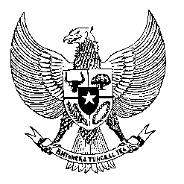

Permanent Mission
of the Republic of Indonesia to the UN, WTO,
and Other International Organizations
in Geneva

STATEMENT BY THE DELEGATION OF THE REPUBLIC OF INDONESIA
AT THE 43rd SESSION OF THE UPR WORKING GROUP
CONSIDERATION OF THE UPR REPORT OF BARBADOS
5 May 2023

Thank you, Madam Vice President,

Indonesia welcomes the delegation of Barbados and thanks for the report.

We commend the Barbados Government’s efforts in addressing human trafficking, preventing and mitigating discrimination on employment, as well as providing housing for vulnerable members in society.

In a constructive spirit, Indonesia recommends the following:

- Reconsider ratifying the Convention Against Torture and the Convention on the Protection of All Migrants Workers and Members of Their Families.

- Ensure that the process of constitutional reform is conducted inclusively and putting human rights as well as rule of law principles accordingly.

- Expedite the process in establishing an independent national human rights institution, in accordance with the Paris Principles.

- Strengthen the protection of children, including by providing the prohibition of corporal punishment for children within the Children Protection Bill and Juvenile Justice Bill.
Finally, we wish the Barbadian delegation a successful review.

Thank you, Madam Vice President.

