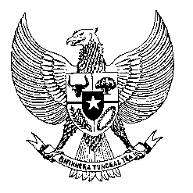

Permanent Mission
of the Republic of Indonesia to the UN, WTO,
and Other International Organizations
in Geneva

Statement
by the Delegation of the Republic of Indonesia
at the 43th Session of the UPR Working Group
Consideration of the UPR Report of Burundi
3 May 2023

Thank you, Mr. Chair,

Indonesia thanks Burundi for its report.

Since its last review, Indonesia welcomes Burundi’s measures to combat gender-based violence, including by establishing the National Gender Commission.

We also commend Burundi’s efforts to address the adverse effects of climate through promoting resilience in its National Development Plan dan National Disaster Risk Reduction Strategy.

In this respect, Indonesia further recommends the following:

- Establish stronger international cooperation to develop and implement social and economic development policies for poverty eradication, food security, and malnutrition;

- Continue awareness-raising campaigns on women’s leadership and adopting reforms to promote women’s participation in decision-making bodies and economic activities;

- Take all necessary measures to ensure the freedom and safety of media and civil society.

Indonesia wishes the delegation of Burundi a successful review.

I thank you.

Words: 132
Max: 1 Min, 10 seconds

