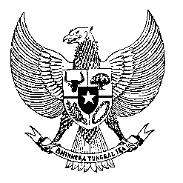

Permanent Mission
of the Republic of Indonesia to the UN, WTO,
and Other International Organizations
in Geneva

STATEMENT BY THE DELEGATION OF THE REPUBLIC OF INDONESIA
AT THE 43rd SESSION OF THE UPR WORKING GROUP
CONSIDERATION OF THE UPR REPORT OF BOTSWANA
3 May 2023

Mr. President

Indonesia thanks Botswana for its report.

We welcome measures taken by Botswana to improve human rights on the ground, including to curb gender-based violence and HIV prevalence.

In the constructive spirit, Indonesia recommends the following:

- Expedite the operationalization of the Office of Ombudsman with the human rights mandate, in accordance with the Paris Principles;

- Strengthen the implementation of legal and institutional frameworks in responding to gender-based violence, discrimination and inequalities;

- Ensure increased participation of vulnerable groups, especially women, youth and persons with disabilities, in the economic empowerment programs.
Finally, we wish Botswana a successful review.

Thank you.

Word Count: 102 words
Max. Speaking Time: 65 seconds.

