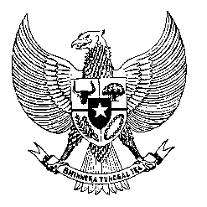

Permanent Mission
of the Republic of Indonesia to the UN, WTO,
and Other International Organizations
in Geneva

Statement
by the Delegation of the Republic of Indonesia
at the 43rd Session of the UPR Working Group
Consideration of the UPR Report of Mali
2 May 2022

Mr. Chair,

Indonesia thanks the delegation of Mali for their report.

Amid the persistent and multidimensional challenges, we welcome the wide-ranging efforts undertaken to remain committed to implementing the UPR recommendations and striving for national reconciliation, lasting peace, and prosperity...

To further improve progress in the promotion and protection of human rights in Mali, Indonesia recommends the following:

First, to ensure adequate resources to support the mandates of its National Human Rights Commission;

Second, to strengthen efforts in response to the food crisis, including expanding care for acute malnutrition in children.

Third, to strengthen measures to improve access and quality of education for all, particularly in rural and conflict-affected areas.

Fourth, to intensify efforts to enact a law to prohibit the use of children in armed conflict.

Indonesia wishes the delegation of Mali a successful review.

I thank you.

