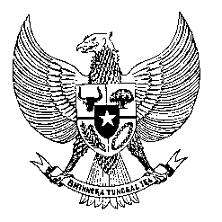

Permanent Mission
of the Republic of Indonesia to the UN, WTO,
and Other International Organizations
in Geneva
STATEMENT BY THE DELEGATION OF THE REPUBLIC OF INDONESIA
AT THE 43rd SESSION OF THE UPR WORKING GROUP
CONSIDERATION OF THE UPR REPORT OF ROMANIA
2 May 2023

Thank you, Mr. Vice President,

Indonesia thanks the delegation of Romania for their report.

We commend Romania’s efforts in advancing the right to education and its efforts to ammend the Criminal Code as well as the Criminal Procedure Code.

To further progress its human rights commitments, Indonesia recommends:

- Promote stronger protection of the rights of migrant workers and their families by considering ratifying the International Convention on the Protection of the Rights of All Migrant Workers and Members of their Families.

- Establish an independent and effective complaint mechanism on the acts of torture and ill-treatment by police officers, with a view to ensuring accountable and non-impunity system of protection for Roma ethnic groups.

- Strengthen measures to end violence against women, including femicides, and ensure better prevention by enacting laws and regulations according to the international standards and practices.

- Expedite the implementation of the new Law on the protection of the whistleblowers in the public interest.

- Address the ethnic-gap access to health insurance by enacting a set of non-discrimination regulations and policies on health care.
Finally, we wish the Romanian delegation a successful review.

Thank you.

Word Count: 190 words
Max. Speaking Time: 1 minute 25 second.

