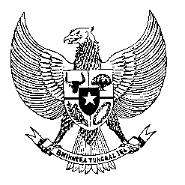

Permanent Mission
of the Republic of Indonesia to the UN, WTO,
and Other International Organizations
in Geneva

STATEMENT BY THE DELEGATION OF THE REPUBLIC OF INDONESIA
AT THE 43rd SESSION OF THE UPR WORKING GROUP
CONSIDERATION OF THE UPR REPORT OF TONGA
1 May 2023

Thank you, Mr. President,

Indonesia thanks the delegation of Tonga for their report.

We recognize Tongas’s significant efforts in implementating previous recommendations and continued commitment to advancing human rights.

We are encouraged by Tonga’s measures to become State Party to a number of international human rights conventions, including CAT, CEDAW and CRPD.

To further progress its human rights commitments, Indonesia recommends:

- Enhance its efforts to conclude the ongoing process of accession to the rest of unratified core international human rights treaties;

- Work towards the establishment of a national human rights institution in line with the Paris Principles; and

- Ensure the effective implementation of national policy measures adopted to protect the rights of vulnerable groups from the impact of climate change and natural disasters.
Finally, we wish the Tongan delegation a successful review.

Thank you, Mr. President.

Word Count: 138 words
Max. Speaking Time: 2 minutes.

