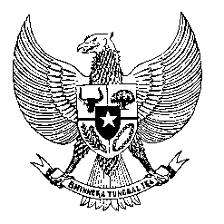

Permanent Mission
of the Republic of Indonesia to the UN, WTO,
and Other International Organizations
in Geneva

Statement
by the Delegation of the Republic of Indonesia
at the 43th Session of the UPR Working Group
Consideration of the UPR Report of France
1 May 2023

Thank you Mr. Chair,

Indonesia thanks France for its report.

Since its last review, Indonesia commends France’s efforts in countering discrimination, racial prejudice, and hate speech.

To further make progresses in the promotion and protection of human rights, Indonesia offers France the following recommendations:

1. Ensure its policy on migrants and refugees, especially of women and children, are in line with international norms to ensure their fundamental human rights;
2. Take further measures in combating discriminatory practices by state and non-state actors based on race, ethnicity, or religion;
3. Strengthen efforts that ensure freedom of expression and religion to protect Muslim women against discriminatory practices and laws.

Indonesia wishes the delegation of France a successful review.

I thank you.
(Max: 55 seconds)

