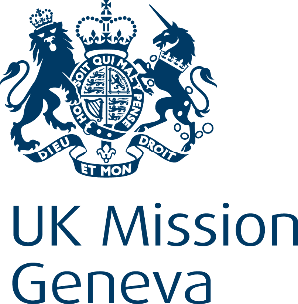

United Kingdom of Great Britain & Northern Ireland
Statement

43rd Universal Periodic Review – Barbados
Friday 5th May 2023

Thank you, Madame Vice President.
Let me start by warmly welcoming the Honourable Minister and his delegation from both Bridgetown and Geneva, and thank him for his presentation this morning.
And let me congratulate Barbados for its recent publication of the Barbados Charter, which reaffirmed rights and freedoms for all.
We also commend Barbados for its abolition of the mandatory death sentence, which the Minister just mentioned, and we encourage the Government to take steps towards full abolition of capital punishment. We also welcome the recent ruling by the Barbados High Court decriminalising consensual same-sex activity, again mentioned by the Minister.
We recommend Barbados:
- Ensure the Constitution guarantees the rights of marginalised groups, including the LGBTIQ+ community.

- Ratify the UN Convention against Torture and Other Cruel, Inhuman or Degrading Treatment or Punishment.

- Implement a comprehensive approach to reduce and end gender-based violence including domestic violence perpetrated against women and girls.

Thank you.

