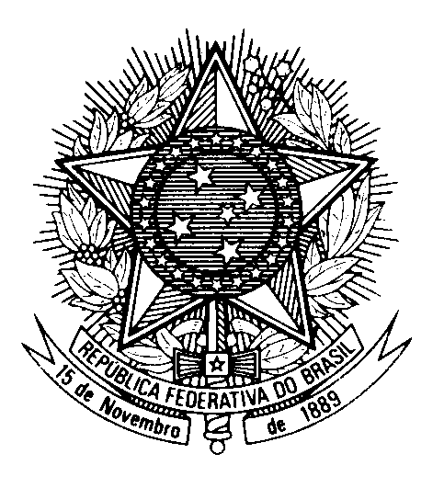
HRC UNIVERSAL PERIODIC REVIEW
BOTSWANA

(Geneva, May 3rd 2023)

STATEMENT OF BRAZIL

Brazil welcomes the delegation of Botswana.

We congratulate Botswana on the regular dialogue with civil society organizations, as shown by the establishment of the National Human Rights Coordination Committee in 2020.

Brazil also commends Botswana for acceding to the Convention on the Rights of Persons with Disabilities.

In a constructive spirit, Brazil recommends that Botswana:

1. repeals Section 164 of the Penal Code following the 2021 Court of Appeal`s ruling and to enact protective legislation to combat discrimination against the LGBTQIA+ community;

2. strengthens the legal and institutional frameworks to protect women against violence, including by explicitly criminalizing marital rape and sexual violence and ensuring the full and effective implementation of the domestic violence act.

We also urge Botswana to consider imposing a moratorium on the death penalty.

We wish Botswana an excellent review.

Thank you.
(136 words)

