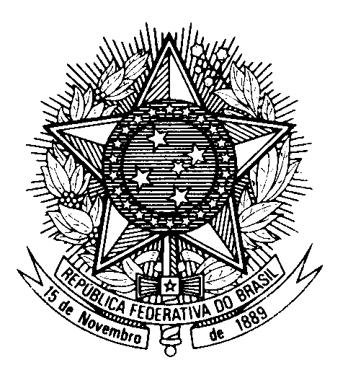

Statement by the Permanent Mission of Brazil to the United Nations Office in the review of Serbia, during the 43rd session of the Working Group on the Universal Periodic Review

(Geneva, 10 May 2023)

Mr. Vice-President,

Brazil welcomes the delegation of Serbia to the fourth cycle of the UPR.

Brazil notes with satisfaction the holding of democratic and plural national elections in Serbia in 2022 and encourages the country to continue enhancing its democratic institutions.

Brazil commends the Serbian government for improving the legal framework to reinforce the independence and accountability mechanisms of the Judiciary.

With a spirit of constructive dialogue, Brazil recommends Serbia:

(i) to adequately prevent, investigate and prosecute attacks against journalists and media workers, while protecting the freedoms of expression and press; and

(ii) to advance in the protection and promotion of the rights of LGBTI persons, including through the adoption of inclusive legislation that guarantees full and equal civil rights for same-sex unions.

We wish Serbia a successful review.

Thank you.

