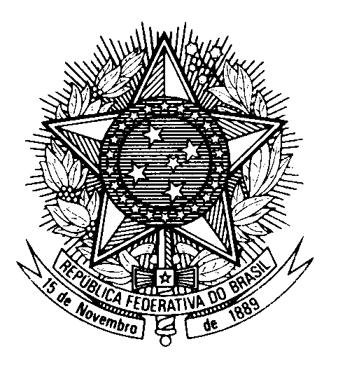

Statement by the Permanent Mission of Brazil to the United Nations Office in the review of Liechtenstein, during the 43rd session of the Working Group on the Universal Periodic Review

(Geneva, 9 May 2023)

Mr. President,

Brazil welcomes the delegation of Liechtenstein to the fourth cycle of the UPR.

We appreciate the Liechtenstein government for its commitment to the implementation of the UN Sustainable Development Goals in the 2021-2025 Programme, including the engagement in international cooperation.

Brazil commends Liechtenstein for ratifying the Council of Europe Convention on Preventing and Combating Violence against Women and Domestic Violence, the Istanbul Convention, as an action to improve the protection of the rights of women and
girls.

With a spirit of constructive dialogue, Brazil recommends Liechtenstein:

(i) to step up efforts to ratify the Convention on the Rights of Persons with Disabilities; and

(ii) to take all necessary measures to implement effective mechanisms for the prevention and protection of children affected by the refugee crisis, specially those who are victims or presumed victims of sexual exploitation and sexual abuse.

We wish Liechtenstein a successful review.

Thank you.

