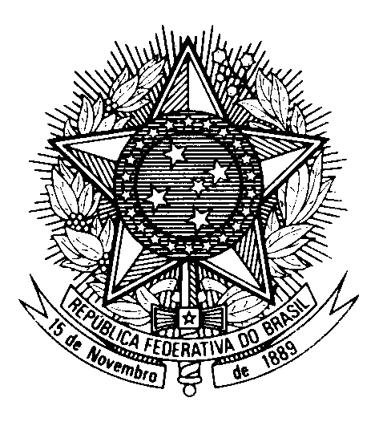

Statement by the Permanent Mission of Brazil to the United Nations Office in the review of Montenegro, during the 43rd session of the Working Group on the Universal Periodic Review

(Geneva, 8 May 2023)

Mr. President,

Brazil welcomes the delegation of Montenegro to the fourth cycle of the UPR.

We welcome the adoption of the 2018 Law on Foreigners and the 2021-2025 Strategy of Migration and Reintegration of Returnees for the protection of refugees and asylum seekers.

Brazil commends the Montenegrin government for its commitment to the UN procedures, having recently received the visits of the Special Rapporteur on Trafficking in Persons, the Special Rapporteur on the Sale and Sexual Exploitation of Children and the Special Advisor of UN Secretary-General on the
Prevention of Genocide.

With a spirit of constructive dialogue, Brazil recommends Montenegro:

(i) to align its legal definition of torture with the Article 1 of the Convention Against Torture and adopt concrete measures to investigate and punish those responsible for cases of torture and ill-treatment of people under police custody; and

(ii) to ensure that all cases of domestic violence, especially against women and girls, are duly investigated and prosecuted and victims are granted adequate legal and social assistance.

We wish Montenegro a successful review.

