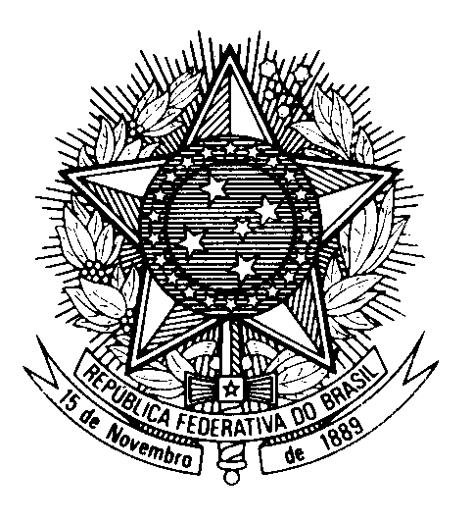

Statement by the Permanent Mission of Brazil to the United Nations in Geneva, during the Universal Periodic Review of Barbados – May 5th 2023 (1min30s)

Brazil welcomes Barbados to the UPR.
We commend the steps taken by Barbados to promote the rights of LGBTQIA+ persons, in particular the Supreme Court’s decision to decriminalize same-sex relations and the Employment Act that proscribes discrimination on grounds of sexual orientation at the workplace.
Brazil also commends the adoption of the Charter of Barbados 2021, which places human rights at the forefront of the country’s commitments through an integrated and sustainable development perspective.
With a constructive spirit, Brazil recommends Barbados:
1. To formally abolish the death penalty and to ratify the Second Protocol to the ICCPR.
2. To strengthen the implementation of the Child Care and Protection Bill and to eliminate the use of corporal punishment against children, both at home and in childcare facilities.
Brazil reiterates its cooperation with Barbados and CARICOM, as well as its commitment to the socioeconomic development of the region as a whole.
Brazil wishes Barbados a successful review.
Thank you.

