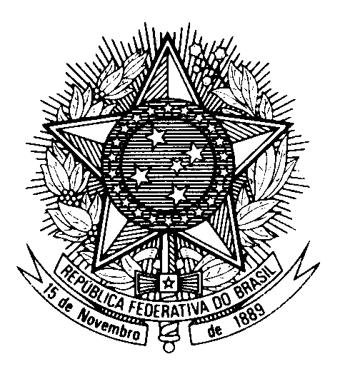

Statement by the Permanent Mission of Brazil to the United Nations in Geneva, during the Universal Periodic Review of the Bahamas – May 3rd 2023

Brazil welcomes the Bahamas to the UPR.
We commend the programs and policies carried out by The Bahamas to eradicate poverty, with a particular focus on promoting food security.
Brazil welcomes the efforts undertaken by The Bahamas concerning the inequality on citizenship transmission in the country, although it notes the lack of an unequivocal law allowing women to pass their nationality on to their children on an equal footing with men.
With a constructive spirit, Brazil recommends:
1. To consider adopting national legislation for recognizing the refugee status and establishing procedures for refugee protection, and
2. To step up efforts for combatting and preventing domestic and gender-based violence, including by criminalizing marital rape in the Sexual Offences Act.
Brazil reiterates its commitment to the regional and bilateral cooperation with The Bahamas, especially in light of the particular challenges the country faces as a Small Island Developing State.
Brazil wishes The Bahamas a successful review.
Thank you.

