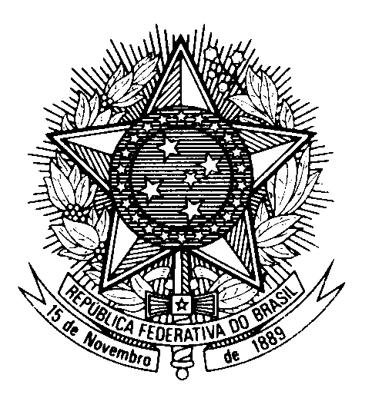

Statement by Ambassador Tovar da Silva Nunes, Permanent Representative of Brazil to the United Nations in Geneva, during the Universal Periodic Review of Romania – May 2nd 2023

Brazil welcomes Romania to the UPR.
We congratulate Romania on the campaign "You are not alone" aimed at preventing and combatting all forms of violence in schools.
Brazil also commends Romania for the National Strategy for Roma Integration, although we note with concern the reports of persistent discrimination against the Roma population, including in the fields of health, education, employment and housing.
In the spirit of constructive dialogue, Brazil recommends:
1. To strengthen legal and policy measures to protect LGBTQIA+ persons from all forms of violence and discrimination, including by ensuring the right of transgender persons to the legal recognition of their identities; and
2. To redouble efforts to enforce legislation aiming to prevent and combat domestic and gender-based violence, promote general awareness of persistent gender stereotypes, and guarantee that victims have adequate access to protective measures and sheltering services.
Brazil would like to recall its recommendation presented at Romania’s last UPR cycle concerning the importance of collecting disaggregated ethnicity data to support public policies.
We wish Romania an excellent review.
Thank you.

