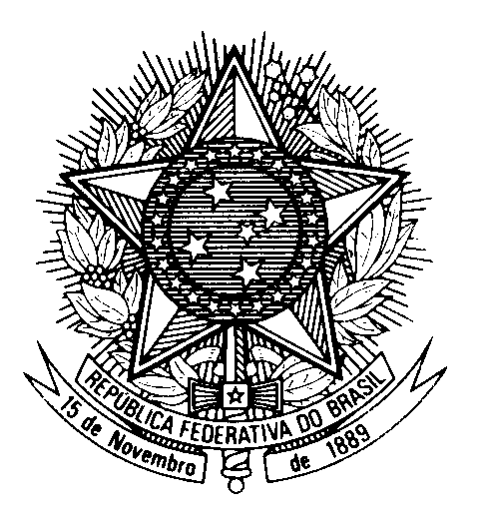
HRC UNIVERSAL PERIODIC REVIEW
TONGA

(Geneva, May 1st 2023)

STATEMENT OF BRAZIL

Brazil welcomes the delegation of the Kingdom of Tonga to the UPR.

We congratulate Tonga on the building of its democratic institutions, on the efforts to advance human rights during the challenging times of the COVID-19 pandemic and the 2021-2022 Hunga Tonga-Hunga Ha`apai Volcanic Eruption and tsunami.

Brazil commends the Tongan Government for the progressive implementation of policies that improve the lives of vulnerable groups of the population, in particular the grant given to persons with disabilities and the programmes catered to them, such as increasing accessibility in public buildings, and also for the expansion of education and the establishment of Family Protection Legal Aide Centres. However, we note that several laws are not in line with the convention on the rights of the child, including with regard to child marriage.

In a spirit of cooperation and constructive dialogue, Brazil recommends to Tonga:

1. To ratify the Convention on the Elimination of All Forms of Discrimination against Women and the Optional Protocol to the Convention, and to update legislation aiming to promote and protect all the rights of women and girls, in particular the right to own land and to inherit it;

2. To decriminalize same-sex relations and put in place legislation to protect individuals from discrimination or violence based on sexual orientation and gender identity.

As recommended in the last UPR, Brazil also urges Tonga to ratify the Convention against Torture and other Cruel, Inhuman or Degrading Treatment or Punishment.

We wish Tonga an excellent review.

Thank you.

