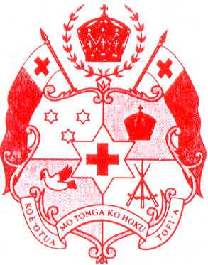
Minister for Foreign Affairs
Nuku‘alofa
Kingdom of Tonga

CLOSING STATEMENT BY H.E HON. FEKITAMOELOA UTOIKAMANU,
MINISTER OF FOREIGN AFFAIRS AND TOURISM
AT THE FOURTH UNIVERSAL PERIODIC REVIEW OF THE KINGDOM OF toNGA
43RD SESSION OF THE UNIVERSAL PERIODIC REVIEW, HUMAN RIGHTS COUNCIL

PALAIS DES NATIONS, GENEVA, SWITZERLAND
5 MAY 2023

Mr. President, H.E Mr. Václav Bálek,
Distinguished Delegates; and
Members of the Troika

- On behalf of the Government of the Kingdom of Tonga, I must first express our sincere gratitude and appreciation to all the Member States for the rich interactive dialogue during Tonga’s fourth universal periodic review on Monday, 1 May 2023.
- Tonga is the very first Pacific Island Country to undergo the fourth universal periodic review. The UPR process continues to be an enriching and productive peer review mechanism to take stock of the standards of human rights issues in Tonga.
- We thank all Member States having provided recommendations for Tonga during the review on Monday.
- For some statistics, let me mention that Tonga received a total of 173 recommendations from 59 Member States. The majority of recommendations addressed ratification of an accession to international instruments and cooperation with human rights mechanisms and welcome suggestions for technical assistance.
- The Government of Tonga will carefully examine all 173 recommendations received. We will respond to the recommendations before the 54th session of the Human Rights Council.
- To be effective, the Government of Tonga wishes to ensure that inclusive and appropriate consultations are conducted on the recommendations received by Tonga. This will also entail for the Government of Tonga to take into consideration its capacity to implement the recommendations. As a small island country recently not only having experienced the COVID impacts but an unprecedented natural disaster, and as a government concerned with an inclusive, sustainable and equitable development for all citizens grounded in the universal rights, high priority will be placed on capacity issues as promises made have to be kept.
- The close examination of the recommendations will allow the Government to prioritize and establish realistic timeframes for the implementation of the recommendations.

Mr President,

- We thank the Vice President, H.E Mr. Muhammadou M.O. Kah and the Universal Periodic Review Working Group for the work undertaken in considering and reviewing Tonga’s fourth National Report for the Universal Periodic Review.
- We express our sincere appreciation to the Secretariat and the Troika States, composed of distinguished delegates of Benin, Czech Republic and the Maldives for their tireless efforts in facilitating and preparing the Working Group Report and to ensure that all the recommendations given to Tonga during the interactive dialogue are accurately reflected in the UPR Working Group Report.
- We also wish to convey our deep appreciation to the Swiss Government for the warm hospitality extended to us since our arrival in Geneva.
- Our gratitude is also extended to all who supported Tonga in progressing its human rights commitments and obligations, including our bilateral development partners, regional organizations including the Pacific Community, other international stakeholders and partners. We look forward to our ongoing collaboration.
- Mr. President, I indeed sincerely thank you and all the distinguished delegates for your time.
- On behalf of our Government, I close by once more acknowledging your invaluable experience and your good will in all your deliberations.

Malo ‘aupito.

