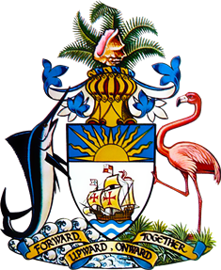

INTERVENTION ON YOUTH

ON THE OCCASION OF THE
FOURTH CYCLE OF THE UNIVERSAL PERIODIC REVIEW
OF
THE COMMONWEALTH OF THE BAHAMAS
AT THE
43RD SESSION OF THE UNIVERSAL PERIODIC REVIEW WORKING GROUP
UNITED NATIONS HUMAN RIGHTS COUNCIL
3RD MAY 2023
GENEVA, SWITZERLAND

Mr. President, the youth of our country, of any country, represents not only our future but our present. Their active participation is vital not only for their own development but of that of our communities and countries. Youth remain key agents for innovation, change and growth in society, technology and the economy.
While we are here to discuss human rights across the spectrum of established human rights instruments, there is a noticeable absence of such an instrument solely dedicated to young people, who face a unique set of challenges, particularly amidst the world evolving, society shifting and communities changing. Despite this gap, The Bahamas is committed to ensuring the voice of our youth is heard and their rights are protected. In fact, we are pleased to have with us a member of our youth, who has ably assisted in efforts to prepare for today, who also serves on the National Youth Advisory Council and works closely with the Department of Youth. This is demonstrative of the dedication of the Bahamas Government to ensure that the youth perspective is engrained in these processes.
Mr. President, as mentioned earlier, this Youth Policy, which was crafted by a dedicated group of young people representing different walks of life, is a priority of the Bahamas Government and we are committed to updating and adopting it in Parliament this year. We will commence with a Ministerial Review, followed by a Consultation with the National Youth Policy Team, a member of which is present with us today. There will be accompanying draft legislation and funding for implementation to ensure the Policy’s efficacy as well as a concurrent streamlining of the National Youth Development Goals.
We are excited about this Policy as we recognize that the rights of young people must be protected, and they must be given the opportunity and resources to create the future they deserve. We look forward to engaging with our young people throughout the process and we welcome the help of the United Nations throughout.

