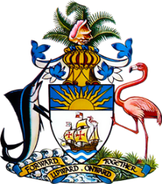

Statement by
Permanent Mission of The Bahamas to the United Nations Office and Other International Organizations in Geneva
at the 42nd Session of the Universal Periodic Review Working Group
Presentation of National Report by the Government of Sri Lanka
1 February 2023 – Morning Session

Thank you, Mr. President.

We thank the Sri Lankan delegation for its report and commend the progress made since the last review.

We note the commitment of the Government of Sri Lanka to education, awareness raising, and training that aims to build a culture of human rights.

We welcome the human rights education program of the Government of Sri Lanka, intended for all law enforcement officers, members of the armed forces, and prison officers throughout their service period. We commend the Sri Lanka Police, notably, the Community Police Division, for conducting regular awareness-raising campaigns to educate the public on existing policies and legislation on the prevention of child abuse, the rights of women and children, and environmental regulations, among other matters.

In a constructive spirit, The Bahamas recommends that Sri Lanka:

Continue its efforts to build national unity and meaningful reconciliation, through robust and all-embracing activities that include training programs and curricula for school children on understanding the cultural and religious values of different communities and on peace and reconciliation.

We wish Sri Lanka every success in this UPR process.

I thank you.

