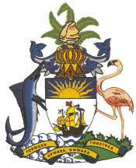

Statement by H.E. Ms. Patricia Hermanns, Ambassador and Permanent Representative of The Bahamas to the United Nations Office and Other International Organizations in Geneva at the
42nd Session of the Universal Periodic Review Working Group
Presentation of National Report by the Government of The Republic of Zambia
30th January 2023

Thank you, Mr. President,

The Bahamas thanks the delegation of the Republic of Zambia for its comprehensive National Report.

The Bahamas commends Zambia for strengthening its commitment to human rights by advancing and enhancing national legislation, including domesticating the Convention on the Rights of the Child and the African Charter on the Rights and Welfare of the Child (Children’s Code Act). We note the strong national agenda for health that includes the establishment of an Adolescent Health Unit in the department of Public Health and the introduction of training of healthcare providers to provide services that are inclusive to adolescents with disabilities.

We further commend Zambia for its introduction of free primary and secondary level education including its efforts in improving access to education for children with special needs.

In a constructive spirit, The Bahamas recommends that Zambia:

- Harmonize all the laws relating to children, including the development of a successor strategy regarding behavioral change toward child marriage.
- Bolster efforts to further increase budgetary allocations in the areas of health and education.

We wish Zambia every success in this UPR process.

I thank you.

