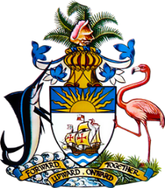

Statement by
Permanent Mission of The Bahamas to the United Nations Office and Other International Organizations in Geneva
at the 42nd Session of the Universal Periodic Review Working Group
Presentation of National Report by the Government of Pakistan
30th January 2023 – Morning Session

Thank you, Madam/Mr. [Vice] President.
The Bahamas thanks the delegation of Pakistan for its comprehensive report and for its active and constructive engagement in this review process
The Bahamas commends Pakistan on its efforts to safeguard and advance basic human rights, including through provision of social safety nets targeting marginalized individuals, despite experiencing unprecedented economic and environmental challenges due to COVID-19 and climate-induced flooding.
We also commend Pakistan on its efforts to upgrade the country’s healthcare infrastructure.
In a constructive spirit, the Bahamas recommends that Pakistan:
- Allocate resources to address the inequality in the education system by building schools, providing school supplies and training teachers.

- Implement a comprehensive strategy aimed at improving water, sanitation, and hygiene in schools.

We wish the delegation Pakistan a successful UPR.
Thank you

