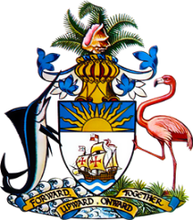

Statement by
Permanent Mission of The Bahamas to the United Nations Office and Other International Organizations in Geneva
at the 42nd Session of the Universal Periodic Review Working Group
Presentation of National Report by the Government of the Republic of Ghana
24th January 2023 – Afternoon Session

Thank you, Madam/Mr. [Vice] President.
The Bahamas extends a warm welcome to a fellow state in the Commonwealth, Ghana. We thank the delegation for its comprehensive report and commitment to this UPR process.
We commend Ghana for the establishment of a National Mechanism for Implementation, Reporting and Follow – ups (NMIRFs) in its Office of the Attorney General and Ministry of Justice to implement the country’s obligations under the international human rights treaties. We applaud the new policies and bills related to education that have been introduced including Free Senior High School, the Commission for Technical and Vocational Education and Training (CTVET) and the Ghana Education Trust Fund Bill.
In a constructive spirit, The Bahamas recommends the following, that Ghana:
    - Continues its efforts to deliver free education to all and to place at the forefront its efforts on removing barriers and promoting access for women, children, and persons with disabilities.
    - Prohibit corporal punishment in education settings; and ensure the legal protection for the right to education of pregnant girls and teenage mothers.

We wish the delegation of Ghana every success in this UPR process.

I Thank you.

