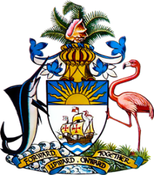

Statement by
Permanent Mission of The Bahamas to the United Nations Office and Other International Organizations in Geneva
at the 42nd Session of the Universal Periodic Review Working Group
Presentation of National Report by the Government of Gabon
24th January 2023 – Morning Session

Thank you, Madam/Mr. [Vice] President.
The Bahamas thanks the delegation of Gabon for its comprehensive report and for its active and constructive engagement in this review process.
We commend the delegation of Gabon for implementing the Gabon Égalité, a strategy to ensure the protection and respect for women’s rights and gender equality. We also commend Gabon on its election to serve on the Executive Board of the United Nations Entity for Gender Equality and the Empowerment of Women (UN-Women) for the period 2023–2025, which further accentuates the country’s efforts to improve the status of women.
In a constructive spirit, The Bahamas submits the following recommendations to the delegation of Gabon:
    - Continue to strengthen the regulatory framework in place to ensure gender equality and combatting violence against women are aligned with international standards.
    - Provide school supplies to children who unable to afford it and assist teachers with enhancing their knowledge and skills in order to provide children with quality education.
    - Consider revising its 1972 Civil Code to enhance legal equality for married women, including by recognising gender-based violence as legitimate grounds for divorce.

We wish the delegation of Gabon every success in this UPR process.

Thank you.

