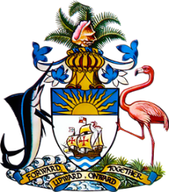

Statement by H.E. Ms. Patricia Hermanns, Ambassador and Permanent Representative of The
Bahamas to the United Nations Office and Other International Organizations in Geneva
at the 42nd Session of the Universal Periodic Review Working Group
Presentation of National Report by the Government of Guatemala
25th January 2023 – Afternoon Session

Thank you, Madam/Mr. [Vice] President.

The Bahamas thanks the delegation of Guatemala for its comprehensive national report and for its active and constructive engagement to this important process.
We commend Guatemala on its accomplishments since its last review process including the strategy to prevent chronic malnutrition, which helped to reduce child mortality among the country’s most vulnerable children.
We further commend Guatemala on its state programmes that provide legal aid to victims of crimes, efforts to increase the number of women in the workforce, and greater funding to prevent trafficking and exploitation of persons.
In a constructive spirit, the Bahamas recommends that Guatemala:
- Strengthen the labor inspection process in order to detect and prevent child labor,

- Ensure that its legislation to address persons with disabilities is consistent with the Convention on the Rights of Persons with Disabilities (CPRD), and

- Bolster efforts to ensure equal access to education, with a view toward improving school attendance and literacy among young girls.

We wish Guatemala every success in this UPR process.

I Thank you.

