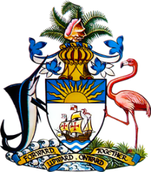

Statement by H.E. Ms. Patricia Hermanns
Ambassador and Permanent Representative of The Bahamas
to the United Nations Office and Other International Organizations in Geneva
at the 42nd Session of the Universal Periodic Review Working Group
Presentation of National Report by the Government of Peru
Wednesday 25th January 2023 – Morning Session

The Bahamas thanks Peru for presenting its national report and commends the country on progress made since the last review.
We congratulate Peru for efforts taken to reduce all forms of discrimination and social inequality through the adoption of the Strategic Plan for National Development up to 2050 and the National Policy for the Modernization of Public Management up to 2030. We also commend Peru on its efforts to eliminate structural discrimination against persons with disabilities through the adoption of the National Multisectoral Policy on Disability for Development up to 2030.
In a constructive spirit, The Bahamas recommends that Peru:
- Ensure that sufficient funds are allocated to enhance the effectiveness of the National Commission against Racism and the Racism Alert Platform
- Continue its efforts to improve the legislative framework for the rights of persons with disabilities and
- Increase consultation with the disabled community regarding regulatory measures that may affect the exercise of their rights.

We wish the delegation of Peru every success during this UPR process.

I thank you.

