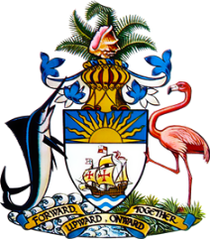

Statement by
Permanent Mission of The Bahamas to the United Nations Office and Other International Organizations in Geneva
at the 42nd Session of the Universal Periodic Review Working Group
Presentation of National Report by the Government of the Argentine Republic
23rd January 2023 – Afternoon Session

Thank you, Madam/Mr. [Vice] President.
The Bahamas thanks the delegation of Argentina for its comprehensive report and for its active and constructive engagement in this important process.
We commend the delegation of Argentina on its National Education Act to ensure equal and quality education from preschool to university level, in public educational institutions in an effort to improve universal access to Education.
In a constructive spirit, The Bahamas submits the following recommendations to Argentina:

- Modernize the training system in place for teachers to ensure that they are equipped with the skills and instructional tools necessary to provide quality education.
- Ensure digital platforms are fully implemented in the school system for dual (in person/ virtual) learning
- Ensure that all communities have access to connectivity.

We wish the delegation of Argentina every success in this UPR process.

I Thank you.

