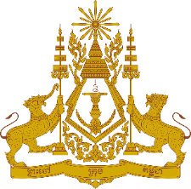
PERMANENT MISSION OF THE KINGDOM OF CAMBODIA
TO THE UNITED NATIONS AT GENEVA

Statement of Cambodia
At the 42nd Session of the UPR Working Group
UPR of the Democratic Socialist Republic of Sri Lanka
01 February 2023
-------

Mr. President!

- Cambodia welcomes the delegation of the Democratic Socialist Republic of Sri Lanka and appreciates the presentation of the national report.

- Cambodia acknowledges Sri Lanka’s continued engagements with UN human rights mechanisms and special procedure. Cambodia commends measures taken by Sri Lanka to implement recommendations since the adoption of its 3rd UPR report.

- In the constructive spirit, Cambodia would like to put forward two recommendations:
  - Continue its efforts to alleviate poverty and promote economic and social sustainable development.
  - Consider taking additional steps to increase women’s representations at the decision-making levels.

- Finally, I wish the delegation of Sri Lanka every success in this review.

Thank you,

*****

