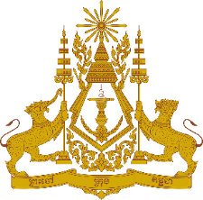
PERMANENT MISSION OF THE KINGDOM OF CAMBODIA
TO THE UNITED NATIONS AT GENEVA

Statement of Cambodia
At the 42nd Session of the UPR Working Group
UPR of the Islamic Republic of Pakistan
30 January 2023
-------

Mr. President!

- My delegation would like to thank Her Excellency Minister of State for Foreign Affairs and her delegation for the comprehensive presentation of the progress made since the adoption of its 3rd UPR report.

- Cambodia commends several initiatives that Pakistan has launched in order to promote rights to education and to protect the rights of vulnerable people, particularly women, children, elderly, minorities and person with disabilities.

- In the constructive spirit, Cambodia would like to put forward two recommendations:
  - Continue taking additional steps to further expand access to quality education by groups in disadvantage situations; and ensure inclusive and equitable quality education service;
  - Continue intensifying efforts to eliminate violence against women.

- Finally, I wish the delegation of the Islamic Republic of Pakistan every success in this review.

Thank you,

*****

