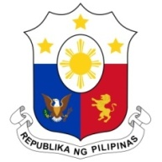
PHILIPPINES

Human Rights Council
42nd Session of the Working Group on the Universal Periodic Review

UPR of PAKISTAN
30 January 2023

Thank you, Mr President.

The Philippines welcomes the Delegation of Pakistan and appreciates the presentation of its national report for the fourth cycle of the Universal Periodic Review.
My Delegation positively notes measures undertaken by the Government of Pakistan to promote and protect human rights in the country pursuant to its national action plan, including capacity building of its national human rights institutions.
In the spirit of constructive dialogue and cooperation, the Philippines recommends the following:
- Enhance the implementation of laws and policies on the elimination of discrimination against women and girls and on combatting gender-based violence, including domestic violence and “honor killings”;

- Ensure the effective enforcement of the Protection of Journalists and Media Professionals Act of 2021: and

- Strictly enforce the prohibition of child domestic labor and consider ratifying the Domestic Workers Convention.

Finally, the Philippines wishes Pakistan a successful UPR.

Thank you, Mr. President. END.

