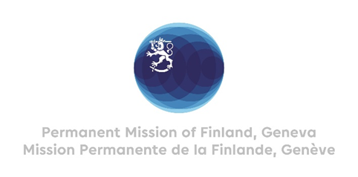

42. Session of the UPR working group Recommendations by Finland

to Zambia

30 January 2023

Mr. President,

Finland welcomes the engagement of Zambia in the UPR process. Finland commends the abolishment of the death penalty in Zambia and the repeal of the law on criminal defamation of the President. Zambia has also made laudable progress towards Economic, Social and Cultural rights by investing significantly into access to education. Finland recommends:

- Firstly, to decriminalize same-sex relationships and guarantee the respect for human rights for all Zambians, including persons identifying themselves as LGBTQI.

- Secondly, to increase finance to education and access to teacher training, in order to improve the quality of education and learning outcomes, and thus complement the commendable introduction of free education up to grade 12.

We wish Zambia a successful UPR review.

Thank you.

