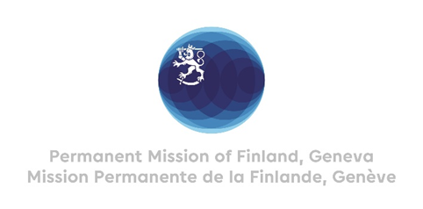

42. Session of the UPR working group Recommendations by Finland

to Pakistan

30 January 2023

Mr. President,

Finland welcomes the engagement of Pakistan in the UPR. We commend that the number of crimes punishable by death in Pakistan was reduced in 2022. Finland recommends:

- Firstly, to abolish the death penalty and, immediately implement a formal moratorium on executions.

- Secondly, to adopt and implement legislation prohibiting forced conversions and take measures to halt abductions, forced marriages and conversions of girls and young women from religious minorities.

- Thirdly, to pass and implement legislation to protect women and girls from gender-based violence, in line with international human rights law.

We wish Pakistan a successful UPR review.

Thank you.

