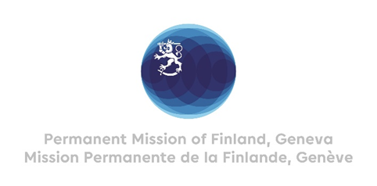

42 Session of the UPR working group Recommendations by Finland to

The Republic of Korea

26th January 2023

Mr President,

Finland welcomes the developments The Republic of Korea has made since the last UPR review process. We welcome the comprehensive report presented, and in a constructive spirit, wish to recommend the following:

- Firstly, to ratify the Second Optional Protocol to the International Covenant on Civil and Political Rights in order to abolish death penalty,
- Secondly, to ratify the Optional Protocol to the Convention against Torture.

We hope that this cycle of UPR will contribute to further improve the human rights situation in the Republic of Korea. Finland wishes all the success to the Republic of Korea in this fourth cycle.

I thank you.

