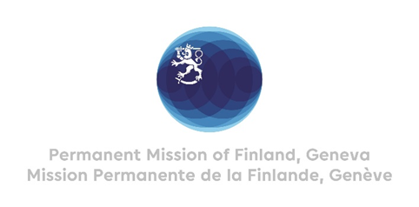

42. Session of the UPR working group Recommendations by Finland

to Guatemala

25 January 2023

Mr. President,

Finland commends the engagement of Guatemala in the UPR process and recognizes the steps taken since the last review. We welcome the creation of the Comprehensive Model for the Attention to women victims of violence.

In the spirit of constructive dialogue, Finland wishes to recommend the following:
1) Firstly, to protect the members of the judicial system, particularly judges and prosecutors, against intimidation, threats and persecution and to ensure their immunity.
2) Secondly, to design and implement legally binding criteria to guarantee the right to Free, Prior and Informed Consent for initiatives affecting Indigenous Peoples.

3) Thirdly, to continue to intensify awareness-raising measures against femicide and violence against women.

We wish Guatemala a successful UPR review.

Thank you.

