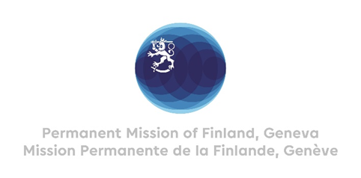

42. Session of the UPR working group Recommendations by Finland

to Peru

25 January 2023

Mr. President,

Finland welcomes the engagement of Peru in the UPR process and commends the steps taken since the last review.

In the spirit of constructive dialogue, Finland wishes to recommend the following:
1) Firstly, to strengthen the protection and support for human rights defenders, including environmental defenders, by effectively implementing the Protective Mechanism.

2) Secondly, to decriminalize abortion in all circumstances and to continue to strengthen access to sexual and reproductive health services for victims of sexual violence.

3) Thirdly, to repeal the Police Protection Law, which raises human rights concerns regarding impunity for disproportionate use of force by law enforcement officials.

We wish Peru a successful UPR review.

Thank you.

