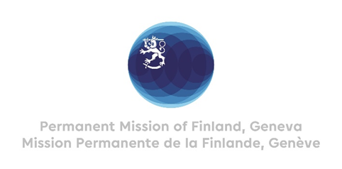

42 Session of the UPR working group Recommendations by Finland

to Ghana

24th January 2023

Mr. President,

Finland welcomes the steps Ghana has taken since the last review and thanks the delegation for the presentation of the report. In the spirit of dialogue and constructive cooperation, Finland recommends:

- Firstly, to abolish the use of death penalty and as a first step to immediately establish an official moratorium on executions and ratify the Second Optional Protocol to the International Covenant on Civil and Political Rights;
- Secondly, to ratify the Optional Protocol to the Convention on the Rights of the Child on the sale of children, child prostitution and child pornography.
Finland wishes Ghana all success with the follow up and implementation of the recommendations.
I thank you.

