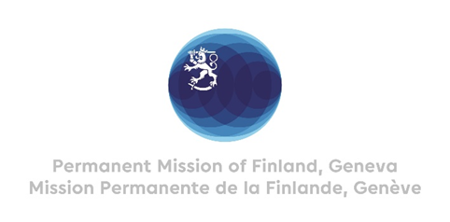

42 Session of the UPR working group Recommendations by Finland

to Gabon

24th January 2023

Mr. President,

Finland congratulates Gabon for the comprehensive report presented. As a fellow member of the Human Rights Council, we appreciate the progress made by Gabon during the last UPR cycle. We commend Gabon for steps taken to protect women against all forms of violence and discrimination. We welcome the opening of Centre d’Accueil Gabon Egalité (Center for women victims of violence) in November 2022.

In the spirit of constructive dialogue,

- Finland recommends Gabon to establish an independent National Human Rights Institution fully compliant with the Paris Principles.
Finland wishes every success with the follow up and implementation of the recommendations received during this fourth cycle of the UPR process.
I thank you.

