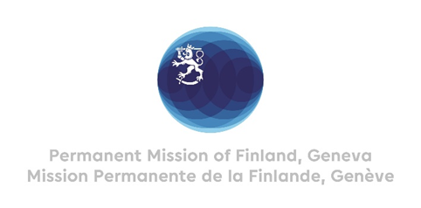

42. Session of the UPR working group Recommendations by Finland

to Argentina

23 January 2023

Mr. President,

Finland welcomes the engagement of Argentina in the UPR process. Finland commends Argentina for continuing to advance the rights of LGBTIQ+ people with progressive legislation as well as for implementing legislation on access to sexual and reproductive health and services, including legalized access to abortion.

In the spirit of constructive dialogue, Finland recommends the following:
- Firstly, to fully implement the Emergency Law 26.160 to prevent the eviction of Indigenous Peoples communities from their territories, in order to guarantee the rights of Indigenous Peoples.

- Secondly, to ensure equal and effective access to sexual and reproductive health services, including safe abortion, in all regions of the country.

We wish Argentina a successful UPR review.

Thank you.

