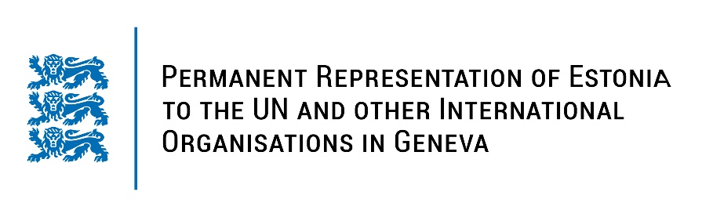
Universal Periodic Review of Sri Lanka
1 February 2023
Intervention by the delegation of Estonia

Estonia welcomes the delegation of Sri Lanka to the 42nd UPR session and thanks for the report and the information provided today.

Estonia notes with appreciation Sri Lanka’s efforts to advance human rights situation by educating law enforcement officers, armed forces and prison officers across the country. Estonia also welcomes the ratification of Optional Protocol to the Convention against Torture.

Estonia would like to recommend to Sri Lanka to:

- ratify the Second Optional Protocol to the International Covenant on Civil and Political Rights, aiming at the abolition of the death penalty;
- ratify the Rome Statute of the International Criminal Court;
- work on advancing the independence and integrity of the judicial system;
- explicitly prohibit corporal punishment of children in law in all settings.

Estonia wishes the delegation of Sri Lanka a successful review meeting.

I thank you!

