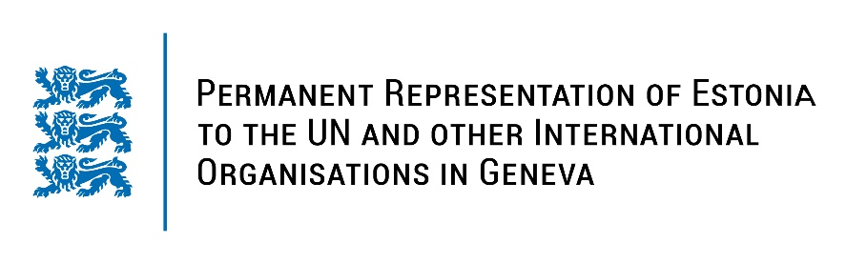
Universal Periodic Review of Japan
31 January 2023
Intervention by the delegation of Estonia

Estonia welcomes the delegation of Japan to the 42nd UPR session and thanks for the report and the information provided today.

Estonia commends Japan for the Fifth Basic Plan for Gender Equality aiming at increasing women’s participation in all fields and combating violence against women. We also note with appreciation the formulation of new comprehensive measures to prevent child abuse in the country.

Estonia would like to recommend to Japan to:
- ensure the effective implementation of the Fifth Basic Plan for Gender Equality and strengthen the legislative framework to promote women’s empowerment and gender equality, in particular by addressing unequal opportunities in the workplace and education as well as in political participation;
- establish an immediate formal moratorium on executions and take concrete steps towards the total abolition of the death penalty.

Estonia wishes the delegation of Japan a successful review meeting.

I thank you!

