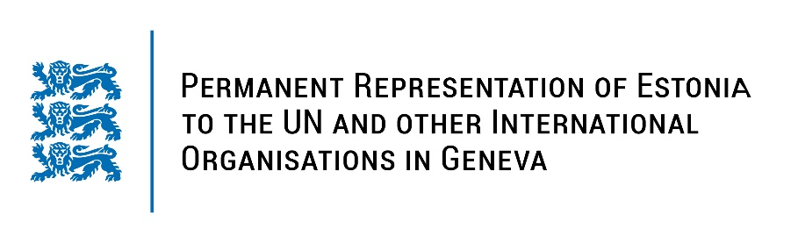
Universal Periodic Review of Pakistan
30 January 2023
Intervention by the delegation of Estonia

Estonia welcomes the delegation of Pakistan to the 42nd UPR session and thanks for the report and the information provided today.

We note with appreciation the establishment of the National Task Force to achieve goals set out in the Action Plan for Human Rights. We also commend Pakistan for raising awareness of laws among women on the prevention of early and forced marriage and their inheritance and property rights. Estonia appreciates Pakistan’s efforts to combat human trafficking and smuggling of migrants.

Estonia would like to recommend to Pakistan to:
- reinstate the moratorium on executions;
- ratify the Second Optional Protocol to the International Covenant on Civil and Political Rights, aiming at the abolition of the death penalty;
- take steps towards criminalising torture and enforced disappearances;
- strengthen the efforts to reduce the maternal mortality rate by improving women’s access to health-care facilities in all provinces.

Estonia wishes the delegation of Pakistan a successful review meeting.

I thank you!

