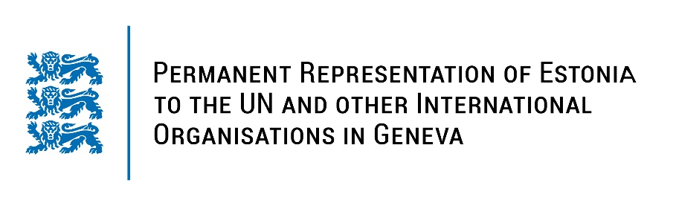
Universal Periodic Review of the Swiss Confederation
27 January 2023
Intervention by the delegation of Estonia

Estonia welcomes the delegation of Swiss Confederation to the 42nd UPR session and thanks for the report and the information provided today.

Estonia highly appreciates the role of Switzerland in promoting human rights throughout the world and a diversified level of human rights protection across the country. Estonia commends Switzerland for taking actions for gender equality and for the adoption of the Equality Strategy 2030. We also welcome the national action plan for the implementation of the Istanbul Convention.

Estonia would like to recommend to Switzerland to:
- continue the work on suicide prevention by ensuring the availability and accessibility of appropriate mental health services throughout the country;
- promote increased women’s representation at all levels of public administration and their participation in management roles in the private sector;
- explicitly prohibit corporal punishment of children in law in all settings, including in the home, schools, childcare institutions, alternative care settings and penal institutions.

Estonia wishes the delegation of Switzerland a successful review meeting.

I thank you!

