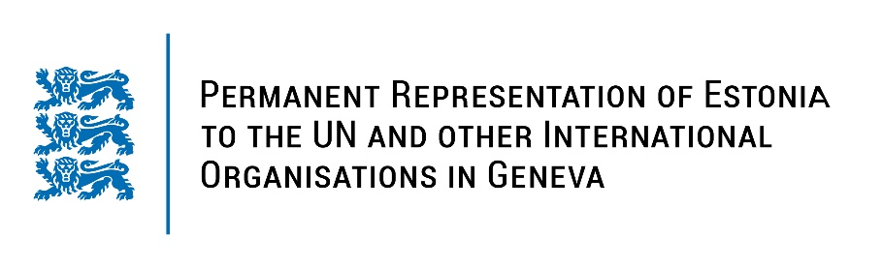
Universal Periodic Review of the Republic of Korea
26 January 2023
Intervention by the delegation of Estonia

Estonia welcomes the delegation of the Republic of Korea to the 42nd UPR session and thanks for the report and the information provided today.

We note with appreciation the positive human rights developments in the Republic of Korea, particularly the implementation of the third National Action Plan (NAP) for the protection of human rights and preparing the fourth NAP. We also commend the Republic of Korea for including human rights education as a subject of school curriculum in 2018. Estonia welcomes the progress that has been made towards gender equality.

Estonia would like to recommend to the Republic of Korea to:
- Reform the Criminal Code and other legislation to ensure universal access to safe and legal abortion;
- Organize public awareness raising campaigns to promote gender equality and counter gender-based violence against women, including women and girls with disabilities;
- Work on a policy strategy to prevent and monitor all forms of violence and abuse against children;
- Consider improving civilian alternatives to the military service for conscientious objectors;
- Ratify the Second Optional Protocol to the International Covenant on Civil and Political Rights, aiming at the abolition of the death penalty.

Estonia wishes the delegation of the Republic of Korea a successful review meeting.

I thank you!

