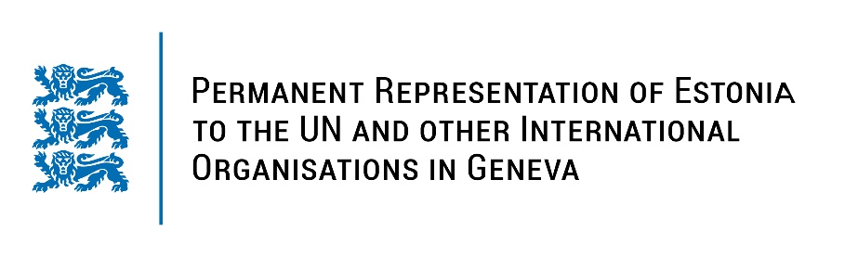
Universal Periodic Review of Benin
26 January 2023
Intervention by the delegation of Estonia

Estonia welcomes the delegation of Benin to the 42nd UPR session and thanks for the report and the information provided today.

We note with appreciation the positive developments in Benin, particularly ratifying human rights treaties as recommended during the previous UPR cycle, criminalising torture and abolishing the death penalty. Estonia also welcomes the progress made in the promotion and protection of women's rights by adopting laws concerning sexual and reproductive health and gender-based violence.

Estonia would like to recommend to Benin to:
- Change the definition of torture to bring it into line with Convention against Torture and Other Cruel, Inhuman or Degrading Treatment or Punishment;
- Raise awareness and enhance training programmes for officials on the absolute prohibition of torture;
- Intensify efforts to guarantee access to sexual and reproductive health information and services by adopting necessary implementing measures;
- Revise the Digital Code, in particular Article 550, which unduly restricts the right to freedom of expression, notably by removing prison sentence for the offence of false information.

Estonia wishes the delegation of Benin a successful review meeting.

I thank you!

