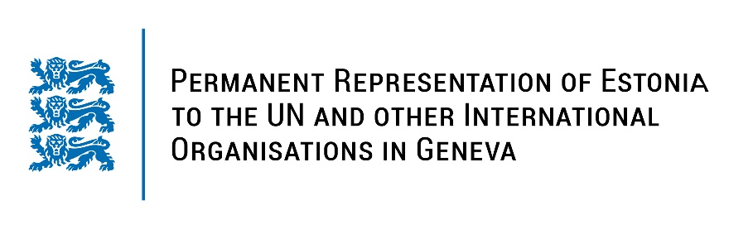
Universal Periodic Review of Peru
25 January 2023
Intervention by the delegation of Estonia

Estonia welcomes the delegation of Peru to the 42nd UPR session and thanks for the report and the information provided today.

We note with appreciation the positive and diversified developments that Peru has made in its international human rights commitments since the last UPR cycle. Estonia especially commends Peru for adopting policies and legislation aiming at reducing violence and discrimination against all women and for the adoption of The National Gender Equality Policy.

Estonia would like to recommend to Peru to:
- guarantee access to sexual and reproductive health information and services, including the possibility of legal and safe abortion for all women and girls;
- ratify the Second Optional Protocol to the International Covenant on Civil and Political Rights, aiming at the abolition of the death penalty;
- take all necessary measures to prevent human rights violations in the context of protests;
- guarantee that complaints of human rights violations that occur during protests are investigated and that all those suspected of criminal responsibility are brought to justice in fair trials.

Estonia wishes the delegation of Peru a successful review meeting.

I thank you!

