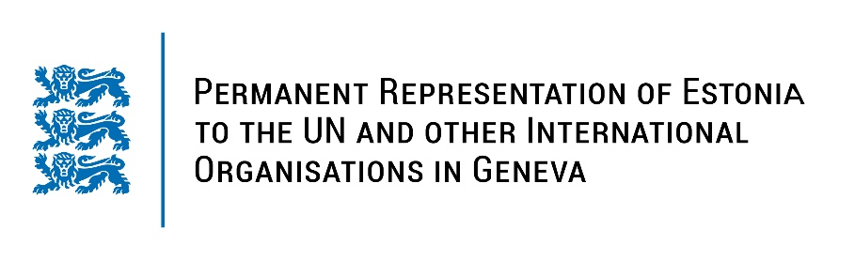
Universal Periodic Review of the Republic of Ghana
24 January 2023
Intervention by the delegation of Estonia

Estonia welcomes the delegation of the Republic of Ghana to the 42nd UPR session and thanks for the report and the information provided today.

Estonia commends Ghana for making efforts to enhance human rights through policy measures and legal framework, like the National Strategic Framework on Ending Child Marriage 2017–2026 and National Plan of Action for the Elimination of Human Trafficking for 2022-2026. We also note with appreciation the system of Stigma and Discrimination Reporting for the most vulnerable groups and necessary measures taken towards implementing the prohibition of all forms of slavery.

Following up on our previous recommendations, Estonia would like to recommend to Ghana to:
- intensify efforts to adopt the Affirmative Action Bill to address discrimination and exclusion of women and gender imbalance;
- adopt measures to ensure universal access to the reproductive health services, including legal and safe abortion, to reduce preventable deaths;
- adopt and implement a sexual and reproductive health policy for adolescents that includes sexual education;
- abolish the death penalty in all legal provisions at the national level;
- ratify the Second Optional Protocol to the International Covenant on Civil and Political Rights, aiming at the abolition of the death penalty.

Estonia wishes the delegation of Ghana a successful review meeting.
Thank you for your attention!

