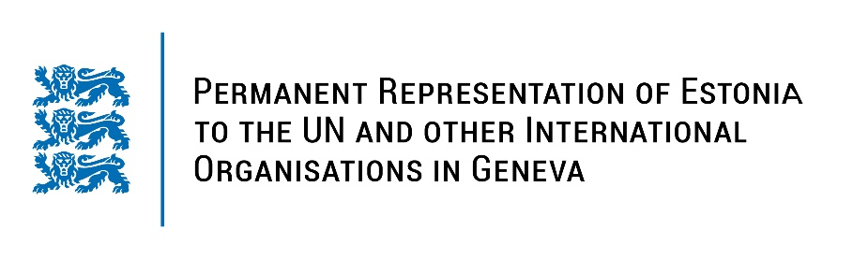

Universal Periodic Review of Gabon
24 January 2023
Intervention by the delegation of Estonia

Estonia welcomes the delegation of Gabon to the 42nd UPR session and thanks for the report and the additional information provided today.

Estonia welcomes Gabon’s recent decision to decriminalise consensual same-sex relations between adults and the amendments to the Civil Code and the Penal Code, which brought significant advances in women's rights and gender equality. Estonia notes with appreciation the establishment of the first centre for female victims of sexual, domestic or any kind of violence in November 2022.

Estonia would like to recommend to Gabon to:
- provide training for law enforcement officers, border control personnel and health-care providers on the early identification of victims of human trafficking;
- ensure the implementation of the Law 009/2016 on access quotas for women and youth by conducting awareness-raising campaigns to empower women’s access to political representation and decision making in the work field;
- uphold freedom of expression and information offline and online by refraining from implementing internet shutdowns;
- work on deteriorating prison conditions and increasing lengths of pre-trial detention.

Estonia wishes the delegation of Gabon every success in the implementation of these recommendations.

I thank you!

